الاسم:عمر محمد محمود حسنين (2)
Chapter 8
Choices:
1) Which of the following is NOT a core feature of NumPy (c)
2) In Pandas, which method is used to group data for aggregation (c)
3) Which library provides high-level visualization functions like heatmap and pairplot (b)
4) Flask is considered a: (a)
5) In Django ORM, a database table is typically represented as: (c)
6) Which library uses tensors and is widely used for deep learning (a)
7) Which of the following can be achieved with SciPy but not directly with NumPy (a)
8) Which statement is true regarding PyTorch (c)
True or false:
1) NumPy arrays are less efficient than Python lists for numerical computations (false)
2. Pandas DataFrame is a two-dimensional labeled data structure (true)
3. Seaborn is built on top of Matplotlib (true)
4. Flask is heavier and more complex than Django ( false)
5. TensorFlow and PyTorch both provide tensor operations and automatic differentiation ( true )
6. Django ORM automatically creates SQL queries for models (true)
Short answer:
- Explain the difference between NumPy and SciPy.
Answer: • NumPy: Provides the basic data structure (arrays) and basic mathematical operations.
• SciPy: Is built on top of NumPy and provides advanced scientific algorithms like integration, optimization, and signal processing.
- What is the purpose of the groupby() function in Pandas? Give an example.
Answer: It splits the data into groups based on some criteria to perform calculations on each group.
• Example: df.groupby('City')['Sales'].sum() calculates total sales for each city.
- Compare Flask and Django in terms of complexity and use cases.
Answer: • Flask: A micro-framework, simple and lightweight. Best for small applications or APIs.
• Django: A full-stack framework, complex and "batteries-included" (has everything). Best for large, enterprise-level web applications.
- Why are tensors important in deep learning frameworks like PyTorch and TensorFlow?
Answer: Tensors are similar to NumPy arrays but can run on GPUs (Graphics Processing Units) to accelerate the massive matrix computations required for training neural networks.
- What is the difference between Matplotlib and Seaborn in visualization?
Answer: • Matplotlib: A low-level library that gives full control but requires more code for complex plots.
• Seaborn: A high-level library built on top of Matplotlib; it creates attractive statistical graphs with much less code.

Problems:
Problem 1:
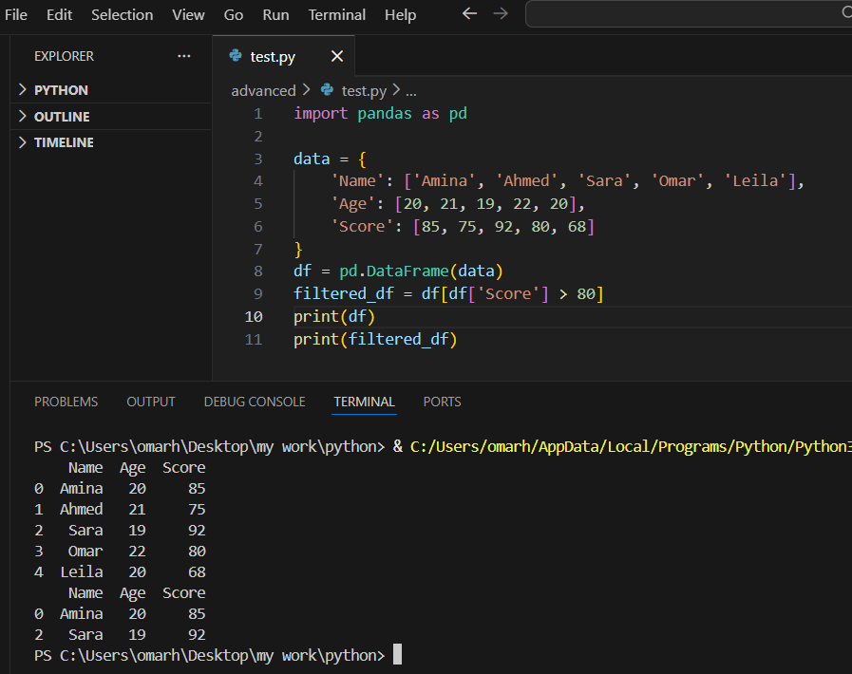
Problem 2 : 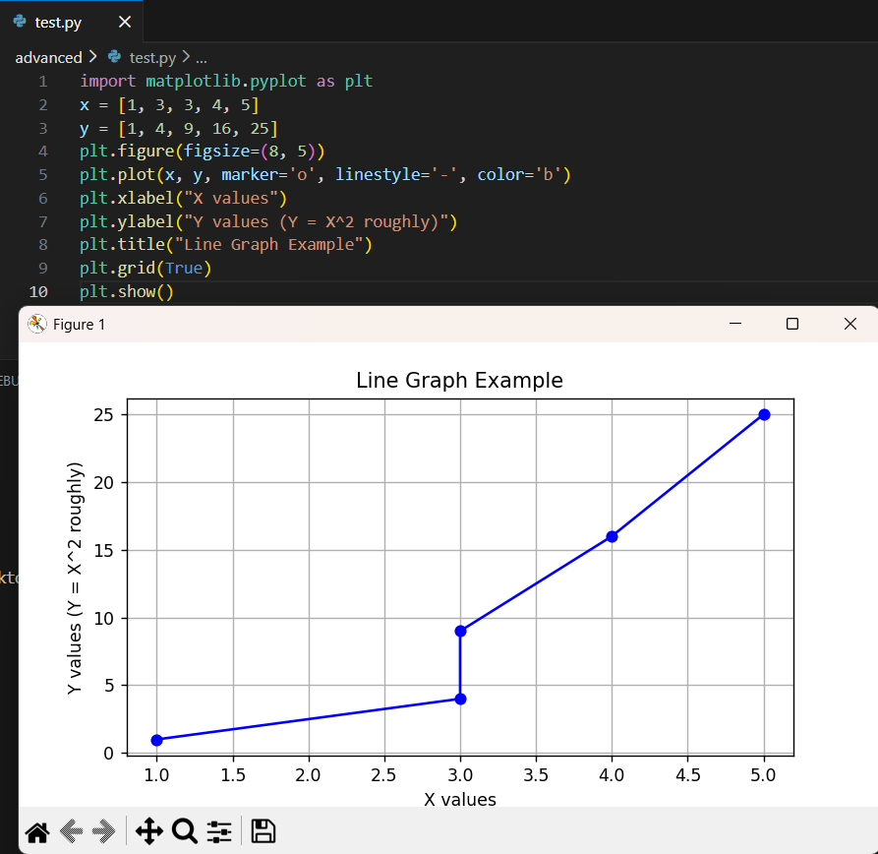
Problem 3: 